Feedback: Functional Model
System Name: Unplanned Eating Pattern Detector
By
Kiran Kumar Palsa

1. Use Case Diagram
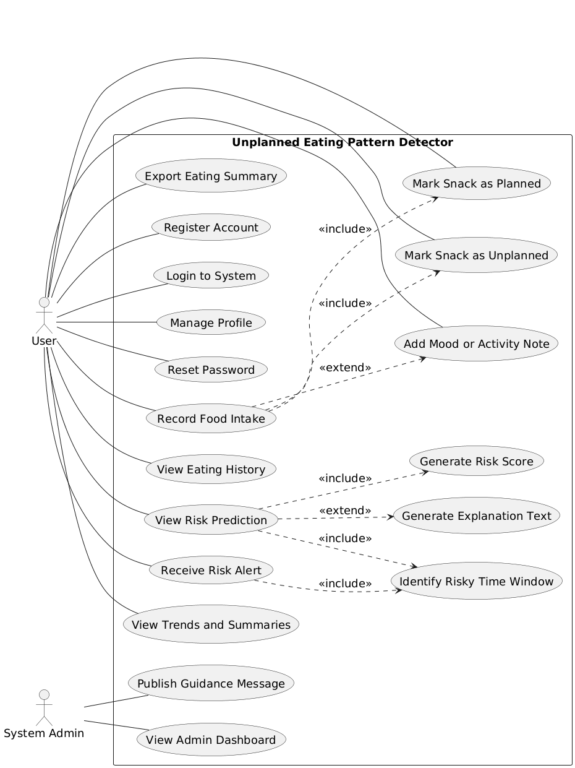
Figure.1 Use Case Diagram
2. Use Case Descriptions
Use Case 1
Use Case Name: Register Account
ID: UC-1
Importance Level: High
Primary Actor: User
Use Case Type: Primary
Stakeholders and Interests:
• User wants to create a secure account.
• System Owner wants valid user registrations.
Brief Description:
Allows a new user to create an account using email and password.
Trigger: User selects Register on the home page.
Type: External
Relationships:
Association: User
Include: None
Extend: None
Generalization: None
Normal Flow of Events:
- User opens the registration page.
- User enters email and password.
- System validates input format.
- System checks email uniqueness.
- System creates user account.
- System shows confirmation message.
Sub-Flows:
• S-1: Validate email and password format.
Alternate/Exceptional Flows:
• A-1: Email already exists.
• A-2: Password does not meet rules.
Related Functional Requirements: 1
Use Case 2
Use Case Name: Login to System
ID: UC-2
Importance Level: High
Primary Actor: User
Use Case Type: Primary
Stakeholders and Interests:
• User wants secure access to personal data.
• System Owner wants controlled access.
Brief Description:
Allows a registered user to log in using valid credentials.
Trigger: User selects Login on the home page.
Type: External
Relationships:
Association: User
Include: None
Extend: None
Generalization: None
Normal Flow of Events:
- User enters email and password.
- System validates credentials.
- System creates user session.
- System opens user dashboard.
- System loads user preferences.
Sub-Flows:
• S-1: Validate credentials.
Alternate/Exceptional Flows:
• A-1: Invalid email or password.
• A-2: Account locked after multiple failures.
Related Functional Requirements: 2

Use Case 3
Use Case Name: Manage Profile
ID: UC-3
Importance Level: Medium
Primary Actor: User
Use Case Type: Primary
Stakeholders and Interests:
• User wants to update personal details.
• System Owner wants accurate user data.
Brief Description:
Allows a user to view and update profile details.
Trigger: User selects Profile Settings.
Type: External
Relationships:
Association: User
Include: None
Extend: None
Generalization: None
Normal Flow of Events:
- User opens profile page.
- System displays current details.
- User edits allowed fields.
- User saves changes.
- System validates input.
- System updates profile.
Sub-Flows:
• S-1: Validate profile fields.
Alternate/Exceptional Flows:
• A-1: Invalid input values.
• A-2: Save operation fails.
Related Functional Requirements: 4

Use Case 4
Use Case Name: Reset Password
ID: UC-4
Importance Level: High
Primary Actor: User
Use Case Type: Primary
Stakeholders and Interests:
• User wants to regain account access.
• System Owner wants secure password reset.
Brief Description:
Allows a user to reset account password using email link.
Trigger: User selects Forgot Password.
Type: External
Relationships:
Association: User
Include: None
Extend: None
Generalization: None
Normal Flow of Events:
- User enters registered email.
- System sends reset link.
- User opens reset link.
- User enters new password.
- System validates password rules.
- System updates password.
Sub-Flows:
• S-1: Send reset email.
Alternate/Exceptional Flows:
• A-1: Email not registered.
• A-2: Reset link expired.
Related Functional Requirements: 5

Use Case 5
Use Case Name: Record Food Intake
ID: UC-5
Importance Level: High
Primary Actor: User
Use Case Type: Primary
Stakeholders and Interests:
• User wants to log daily food.
• System Owner wants accurate data.
Brief Description:
Allows a user to record food item with time and snack type.
Trigger: User selects Add Food Record.
Type: External
Relationships:
Association: User
Include: Mark Snack as Planned, Mark Snack as Unplanned
Extend: Add Mood or Activity Note
Generalization: None
Normal Flow of Events:
- User opens food entry form.
- User enters food item and time.
- User selects snack type.
- User marks planned or unplanned.
- User submits the form.
- System validates inputs.
- System saves record.
Sub-Flows:
• S-1: Select snack type.
Alternate/Exceptional Flows:
• A-1: Required fields missing.
• A-2: Invalid time format.
Related Functional Requirements: 6, 7, 8, 9
Use Case 6
Use Case Name: View Eating History
ID: UC-6
Importance Level: Medium
Primary Actor: User
Use Case Type: Primary
Stakeholders and Interests:
• User wants to review eating history.
• System Owner wants clear reports.
Brief Description:
Allows a user to view daily and weekly eating history.
Trigger: User selects View History.
Type: External
Relationships:
Association: User
Include: Filter History by Date Range
Extend: None
Generalization: None
Normal Flow of Events:
- User opens history page.
- System loads eating records.
- User selects daily or weekly view.
- User applies date filter.
- System displays results.
Sub-Flows:
• S-1: Apply date filter.
Alternate/Exceptional Flows:
• A-1: No records found.
• A-2: Data loading error.
Related Functional Requirements: 14, 15, 23

Use Case 7
Use Case Name: View Risk Prediction
ID: UC-7
Importance Level: High
Primary Actor: User
Use Case Type: Primary
Stakeholders and Interests:
• User wants to see risk results.
• System Owner wants model output visible.
Brief Description:
Displays risk score, risk label, and explanation for snack timing.
Trigger: User opens Risk Prediction page.
Type: External
Relationships:
Association: User
Include: Generate Risk Score, Identify Risky Time Window
Extend: Generate Explanation Text
Generalization: None
Normal Flow of Events:
- User opens risk page.
- System retrieves eating data.
- System generates risk score.
- System identifies risky time window.
- System displays risk label and score.
- System shows explanation text.
Sub-Flows:
• S-1: Load model results.
Alternate/Exceptional Flows:
• A-1: No data available.
• A-2: Model service unavailable.
Related Functional Requirements: 16, 17, 18, 19

Use Case 8
Use Case Name: Receive Risk Alert
ID: UC-8
Importance Level: High
Primary Actor: User
Use Case Type: Primary
Stakeholders and Interests:
• User wants timely alerts.
• System Owner wants reliable delivery.
Brief Description:
Sends a gentle alert before predicted risky snack time.
Trigger: System detects upcoming risky time window.
Type: Temporal
Relationships:
Association: User
Include: Identify Risky Time Window
Extend: None
Generalization: None
Normal Flow of Events:
- System checks upcoming risky window.
- System prepares alert message.
- System sends notification.
- User receives alert.
- User views alert message.
Sub-Flows:
• S-1: Prepare notification content.
Alternate/Exceptional Flows:
• A-1: Alerts disabled by user.
• A-2: Notification delivery fails.
Related Functional Requirements: 20, 21

Use Case 9
Use Case Name: View Trends and Summaries
ID: UC-9
Importance Level: Medium
Primary Actor: User
Use Case Type: Primary
Stakeholders and Interests:
• User wants trend insights.
• System Owner wants useful summaries.
Brief Description:
Displays charts and summaries of unplanned snacking trends.
Trigger: User opens Trends page.
Type: External
Relationships:
Association: User
Include: View Frequent Snack Time Windows
Extend: None
Generalization: None
Normal Flow of Events:
- User opens trends page.
- System loads historical data.
- System generates charts.
- System shows frequent snack windows.
- User reviews summaries.
Sub-Flows:
• S-1: Generate trend charts.
Alternate/Exceptional Flows:
• A-1: Not enough data.
• A-2: Chart generation fails.
Related Functional Requirements: 16, 22

Use Case 10
Use Case Name: Export Eating Summary
ID: UC-10
Importance Level: Medium
Primary Actor: User
Use Case Type: Primary
Stakeholders and Interests:
• User wants a downloadable summary.
• System Owner wants correct report export.
Brief Description:
Allows user to export eating summary as a PDF file.
Trigger: User selects Export Summary.
Type: External
Relationships:
Association: User
Include: None
Extend: None
Generalization: None
Normal Flow of Events:
- User selects export option.
- System prepares eating summary.
- System generates PDF file.
- System provides download link.
- User downloads the file.
Sub-Flows:
• S-1: Prepare PDF report.
Alternate/Exceptional Flows:
• A-1: Export service unavailable.
• A-2: File generation fails.
Related Functional Requirements: 24

Use Case 11
Use Case Name: Publish Guidance Message
ID: UC-11
Importance Level: Medium
Primary Actor: System Admin
Use Case Type: Primary
Stakeholders and Interests:
• Admin wants to share guidance.
• Users want helpful tips.
Brief Description:
Allows admin to publish supportive guidance to users.
Trigger: Admin selects Publish Message.
Type: External
Relationships:
Association: System Admin
Include: None
Extend: None
Generalization: None
Normal Flow of Events:
- Admin opens guidance editor.
- Admin enters message.
- Admin submits message.
- System validates content.
- System publishes message.
Sub-Flows:
• S-1: Validate message content.
Alternate/Exceptional Flows:
• A-1: Message is empty.
• A-2: Publish fails.
Related Functional Requirements: 29, 30

Use Case 12
Use Case Name: View Admin Dashboard
ID: UC-12
Importance Level: High
Primary Actor: System Admin
Use Case Type: Primary
Stakeholders and Interests:
• Admin wants trend visibility.
• System Owner wants system oversight.
Brief Description:
Displays anonymized snack trends and alert counts.
Trigger: Admin opens dashboard.
Type: External
Relationships:
Association: System Admin
Include: None
Extend: None
Generalization: None
Normal Flow of Events:
- Admin logs into admin panel.
- System loads dashboard data.
- System shows risky time windows.
- System shows alert frequency counts.
- Admin reviews trends.
Sub-Flows:
• S-1: Load dashboard data.
Alternate/Exceptional Flows:
• A-1: Data load error.
• A-2: Dashboard unavailable.
Related Functional Requirements: 26, 27, 28, 31, 32

Use Case 13
Use Case Name: Mark Snack as Planned
ID: UC-13
Importance Level: Medium
Primary Actor: User
Use Case Type: Included
Stakeholders and Interests:
• User wants to tag snacks correctly.
• System Owner wants accurate data.
Brief Description:
Marks a food record as planned snack.
Trigger: User selects Planned option.
Type: External
Relationships:
Association: User
Include: None
Extend: None
Generalization: None
Normal Flow of Events:
- User selects planned option.
- System tags record as planned.
- System saves updated record.
- System updates eating log.
Sub-Flows:
• S-1: Save planned tag.
Alternate/Exceptional Flows:
• A-1: Save fails.
Related Functional Requirements: 7

Use Case 14
Use Case Name: Mark Snack as Unplanned
ID: UC-14
Importance Level: High
Primary Actor: User
Use Case Type: Included
Stakeholders and Interests:
• User wants to tag unplanned snacks.
• System Owner wants risk accuracy.
Brief Description:
Marks a food record as unplanned snack.
Trigger: User selects Unplanned option.
Type: External
Relationships:
Association: User
Include: None
Extend: None
Generalization: None
Normal Flow of Events:
- User selects unplanned option.
- System tags record as unplanned.
- System saves updated record.
- System updates eating log.
Sub-Flows:
• S-1: Save unplanned tag.
Alternate/Exceptional Flows:
• A-1: Save fails.
Related Functional Requirements: 8

Use Case 15
Use Case Name: Add Mood or Activity Note
ID: UC-15
Importance Level: Medium
Primary Actor: User
Use Case Type: Extended
Stakeholders and Interests:
• User wants to record context.
• System Owner wants better analysis data.
Brief Description:
Adds mood or activity note to a food record.
Trigger: User enters a note during food entry.
Type: External
Relationships:
Association: User
Include: None
Extend: Record Food Intake
Generalization: None
Normal Flow of Events:
- User enters short note.
- System validates note length.
- System saves note.
- System confirms update.
Sub-Flows:
• S-1: Validate note text.
Alternate/Exceptional Flows:
• A-1: Note too long.
• A-2: Save fails.
Related Functional Requirements: 10, 11

Use Case 16
Use Case Name: Generate Risk Score
ID: UC-16
Importance Level: High
Primary Actor: User (Indirect)
Use Case Type: Included
Stakeholders and Interests:
• User wants risk feedback.
• System Owner wants correct model output.
Brief Description:
Generates risk score using eating data.
Trigger: System processes new food record.
Type: Internal
Relationships:
Association: User
Include: None
Extend: None
Generalization: None
Normal Flow of Events:
- System collects recent eating data.
- System runs model logic.
- System generates risk score.
- System stores result.
Sub-Flows:
• S-1: Run prediction model.
Alternate/Exceptional Flows:
• A-1: Model service unavailable.
• A-2: Insufficient data.
Related Functional Requirements: 17

Use Case 17
Use Case Name: Identify Risky Time Window
ID: UC-17
Importance Level: High
Primary Actor: User (Indirect)
Use Case Type: Included
Stakeholders and Interests:
• User wants timely warnings.
• System Owner wants correct detection.
Brief Description:
Identifies risky snack time windows from history.
Trigger: System analyzes eating patterns.
Type: Internal
Relationships:
Association: User
Include: None
Extend: None
Generalization: None
Normal Flow of Events:
- System analyzes snack timing.
- System detects risky windows.
- System stores risky window.
- System prepares alert logic.
Sub-Flows:
• S-1: Analyze timing patterns.
Alternate/Exceptional Flows:
• A-1: Not enough data.
• A-2: Analysis fails.
Related Functional Requirements: 16

Use Case 18
Use Case Name: Generate Explanation Text
ID: UC-18
Importance Level: Medium
Primary Actor: User (Indirect)
Use Case Type: Extended
Stakeholders and Interests:
• User wants clear results.
• System Owner wants transparency.
Brief Description:
Generates explanation for risk prediction results.
Trigger: User views risk prediction details.
Type: Internal
Relationships:
Association: User
Include: None
Extend: View Risk Prediction
Generalization: None
Normal Flow of Events:
- System gathers model factors.
- System prepares explanation text.
- System displays explanation.
- User reads explanation.
Sub-Flows:
• S-1: Summarize key factors.
Alternate/Exceptional Flows:
• A-1: Explanation generation fails.
Related Functional Requirements: 19

3. Activity Diagram
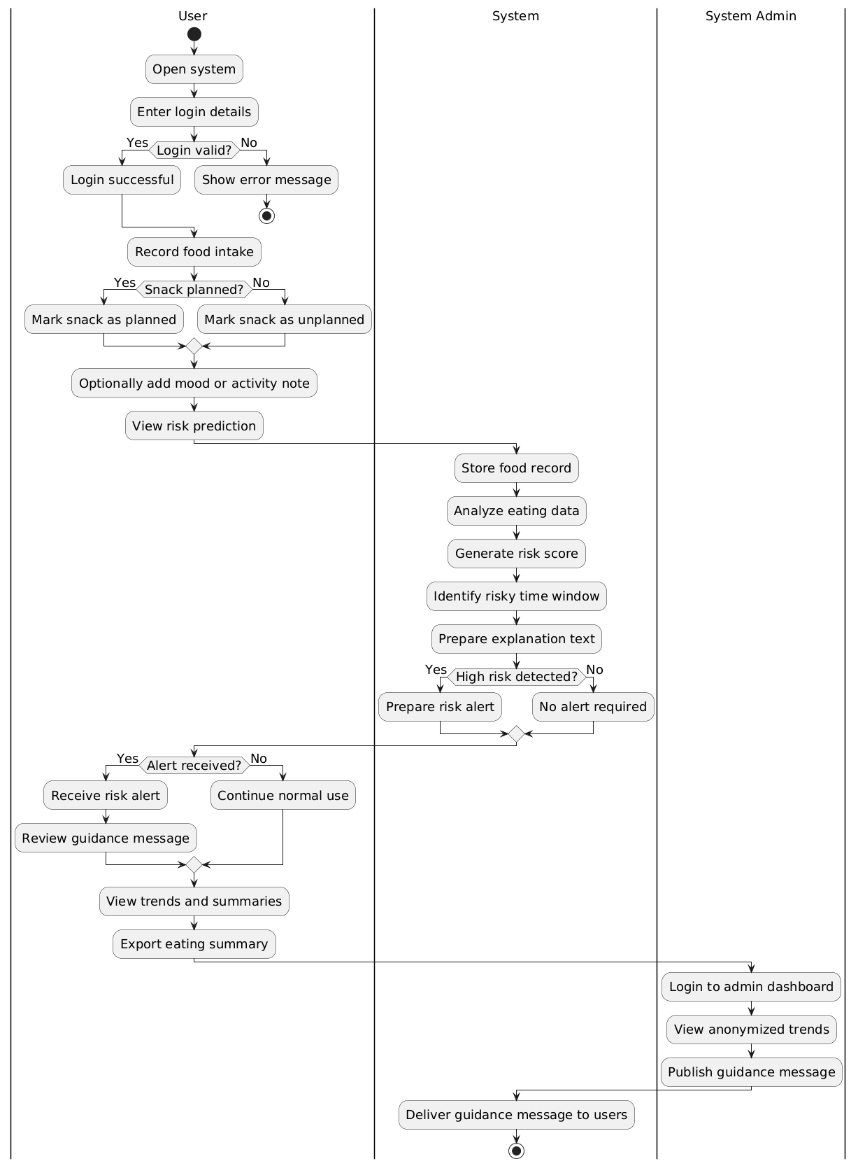
Figure.2 Activity Diagram

